A RadioPC for MyriaNed

Myrianed is a wireless sensor network project of Devlab. It investigates protocols at various levels. For the study of these protocols a test facility is required. For this, test hardware is developed using an RF front-end, an ADC/DAC, an FPGA and a high-speed USB interface. This hardware is not application-specific.

The hardware can be controlled by a software defined radio framework like GNU Radio. Together it can be set-up as a test facility, which can be used for protocol-analysis, performance and quality measurements, and actively participate in the communication with the wireless sensor network.

The aim of the master’s project is to:

- Define the requirements for the firmware controlling the hardware, needed for GNU Radio
- Port GNU Radio to be able to use this firmware and hardware
- Define and implement test-procedures for protocol-analysis and performance measurements
- Define and implement SDR functionality for participation in the WSN communication

The GNU Radio project can be found at: http://gnuradio.org/trac

Further information on GNU Radio can be found at:

- "Exploring GNU Radio" http://www.gnu.org/software/gnuradio/doc/exploring-gnuradio.html. A high level overview of GNU Radio and the USRP. This is an revised and expanded version of the June 2004, Linux Journal article.
- The Doxygen generated API docs http://gnuradio.org/doc/doxygen/hierarchy.html
- Listening to FM Radio in Software, Step by Step. Linux Journal, September 2004. http://www.linuxjournal.com/article.php?sid=7505
- "How to Write a Signal Processing Block" http://www.gnu.org/software/gnuradio/doc/howto-write-a-block.html. A detailed tutorial on writing GNU Radio Signal Processing blocks

Attached is preliminary information on the test hardware.

The test hardware consists of two modules, an RF front-end for reception or transmission at specific a frequency band and bandwidth, and a base module consisting of an AD/DA front-end, an FPGA and a high-speed USB interface.

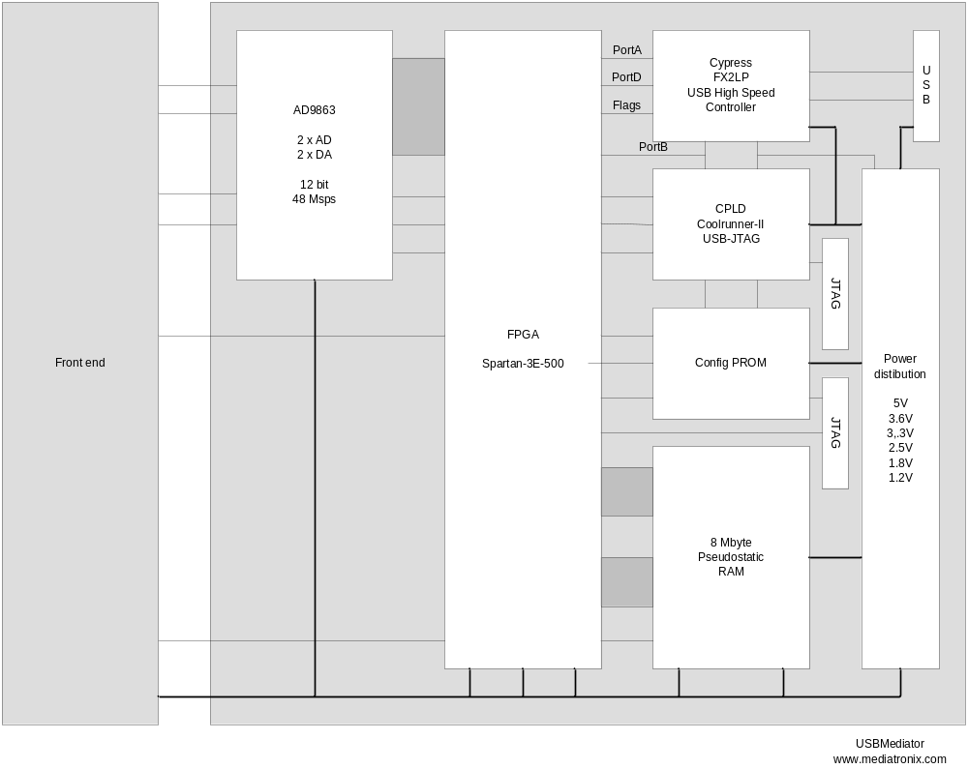

Note: Basic firmware for the FPGA and USB chip is available but needs to be adapted to the requirements of GNU Radio.

For the MyriaNed wireless sensor network a receive-only module for the 2400-2480 MHz band is developed, containing an LNA, a VCO/PLL and a quadrature mixer.

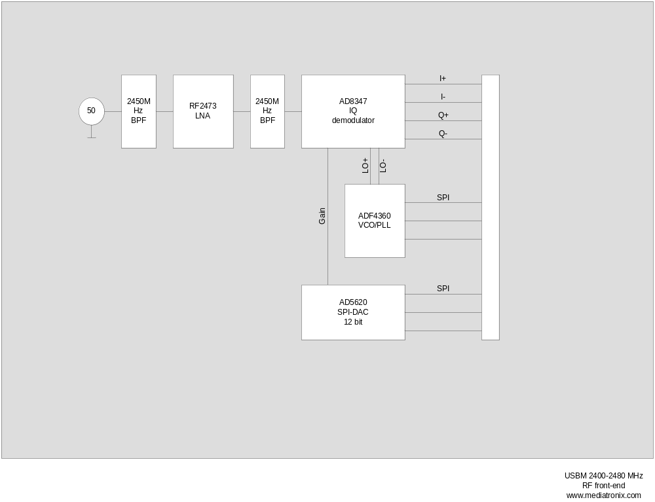
Other modules currently being developed are receiving front- ends for the 400-900 MHz band, 800-2100MHz band. A transmit-only module for the 2400-2480MHz band, which can be used together with the receive-only module mentioned. Also a dual-IO base band module is available for 0.1-20 MHz signals.

Further there are non-SDR modules planned for Camera-link, high definition audio, professional digital audio and video links, like DVB-ASI, AES3, HD-SDI etc.

